Case studies on rights violations, best and worst practices at factory level in RMG and Tannery Sector in Bangladesh

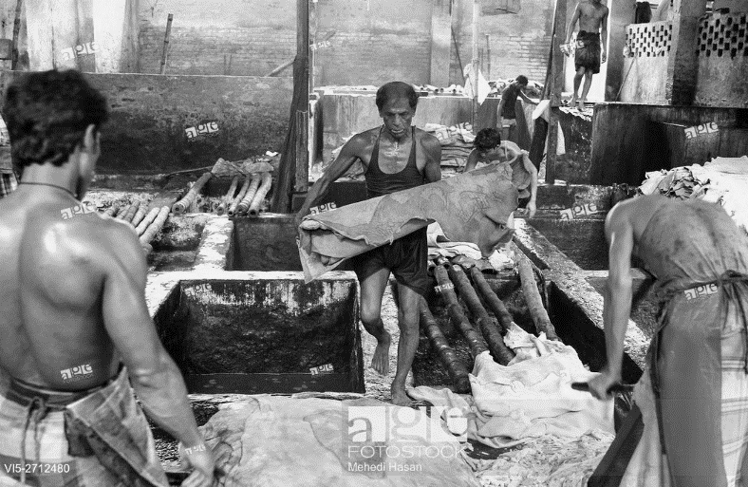
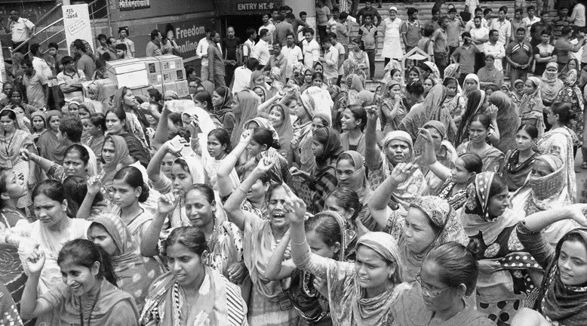

S

Sustainable and Responsible Actions for Making Industries Care (SHRAMIC) Project

Supported by:

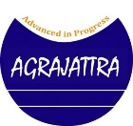

Introduction:
The contribution of Readymade Garment (RMG) industry is inevitable towards the economic development of Bangladesh. The RMG industry has played a significant role in terms of earning foreign currency, creating employment opportunities, women empowerment and overall social change. Approximately 4 million workers, mostly women are employed in RMG sector. Despite having many positive elements, the sector faces many challenges that would include lack of social business standards, safety at workplace, rights violations of the workers etc.
On the other hand, Tannery industry is one of the oldest production sector in Bangladesh and having enormous business potential. Since its inception the Tannery industry proved itself as profitable sector. However, the Tannery industry has been negatively impacting on human lives and environment since long. This industry has failed to a large extent to ensure health and safety of its workers. As a result, this potential sector could not achieve the expected level of success.
Safe work place is a basic right of the workers. Decent work place is a prerequisite for ensuring a just society. Decent and quality work place lead to higher productivity through developing working capacity of the workers. Besides, safe work place ensures healthy workforce and contributes to realize basic needs through reducing accidents and health related cost.
Various accidents that occurred in the recent past in the RMG and Tannery sector created an opportunity for people and institutions affiliated with these two sectors to rethink how the working environment and safety can be ensured. As a result, the Government of Bangladesh, factory owners, foreign buyers and other concerned persons initiated concerted efforts and some positive changes are already visible. However, still a good number of factories lagging behind and need to take efforts for improving working condition and safety.
Under the above-mentioned circumstances, ActionAid Bangladesh with support from the European Union initiated a project titled “Sustainable and Responsible Actions for Making Industries Care (SHRAMIC)” aiming at accelerating an inclusive and sustainable economic growth through creating decent working environment in RMG and Tannery sector of Bangladesh.
The specific objective of the project is to develop capacity of the Trade Unions and Civil Society Organizations affiliated with the RMG and Tannery sector so that they can effectively represent the workers and make the owners/management of the factories accountable towards implement the Labour Law. These case studies have been prepared as part of documentation of the successes and challenges of the project.
Methodology:
The relevant project documents were reviewed for having a clear idea about the project, its objectives, major activities and expected results. The topics for preparing case studies were finalized in consultation with the relevant project personnel. Later, information were collected from all partner organizations and direct and indirect beneficiaries through field visits. Individual discussion and Focus Group Discussion were conducted with Project managers, Lead Trainers, members of the Workers’ Café, members of the Trade Unions, Participatory Committee members at factory level, youth leaders and representatives of the factories.
Acknowledgement

Our sincere gratitude to all individuals and institutions who provided with valuable information and opinions for making these case studies

Workers’ Café: An Alternative Platform for the Workers

The workers of the RMG and Tannery industry are often exposed to various forms of abuse and exploitations and living under inhuman condition. They are deprived of their minimum rights as worker. They are subject to social, economic, cultural and political irregularities and mismanagement both inside and outside of the factories. Specially, women workers faces higher levels of abuse and exploitations. In most cases, these workers are unorganized and cannot protest against the ongoing abuse and exploitations. On one hand, they are not fully aware about their rights and entitlements and on the other hand, they are unorganized. As a result, it has not been possible to raise their voice strongly. The existing trade union activities often fail to represent these workers. They do not have their own platform through which they could learn about their rights, share their troubles, raise their voice and spend some time for mental refreshment.
Under the above-mentioned situation, the SHRAMIC Project established a total of 25 Workers’ Café in Dhaka and Chottogram for the RMG and Tannery workers. One of the uniqueness of the Workers’ Café is that these Cafes are not being run like traditional social or workers organizations. Rather, its operational strategies were developed based on the demand and expectations of the workers. Most of the activities are implemented in an informal nature in order to accommodate the needs and aspirations of the workers. The Workers’ Café provides awareness regarding the rights and responsibilities of the workers in alignment with the Labour Act as well as recreational opportunities to secure the mental tranquility of the workers. The Workers’ Café has genuinely become the platform of the workers through ensuring their participation at all stages of the decision making process for running the Café.
The Workers’ Café is open for all male and female workers of the RMG and Tannery sector. However, about ninety percent Café members are female. As most of the female workers face higher level of abuse and exploitations at home and workplace and they have hardly any opportunity to ventilate their trouble, therefore, they found the Café as a learning and recreational place for them.
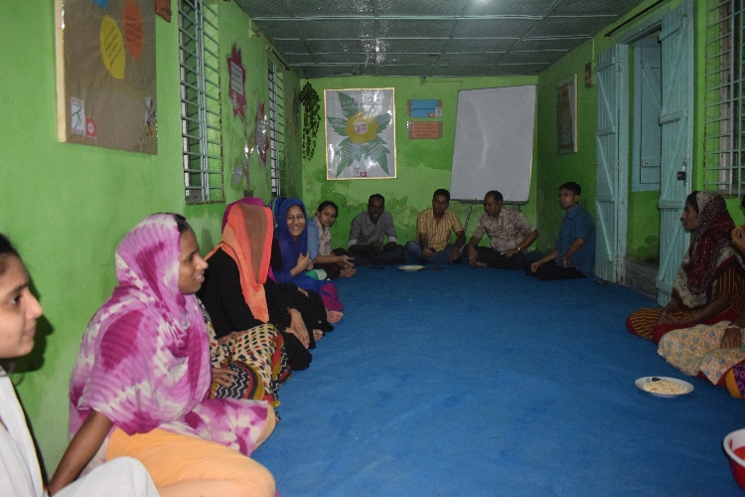
Workers’ Café is our own place. We run the Café ourselves. We decide what we will do at the Café and how we will do it. Whenever we get time we come to the Café. We discuss our problems and resolve it jointly.

Champa Akter
Garment Worker and Café Member
Chottogram

One of the most important services provided by the Café was creating awareness through Non-class training session among the workers regarding their rights and responsibilities based on the Labour Act. Besides, they were provided training on good governance which included how to form organization, rules and regulation to run an organization, fund raising, accounting etc.
Quite apart from the awareness raising, the Workers’ Café provided opportunity for playing, recreation and refreshment for the Cafe members. The members were also able to share their personal problems and got solutions. In addition, Workers’ Café helped its members to resolve their work related problems. More number of members showed up in the Café during weekends and government holidays. A good number of members come to the Café 4-5 days in a week after their work.

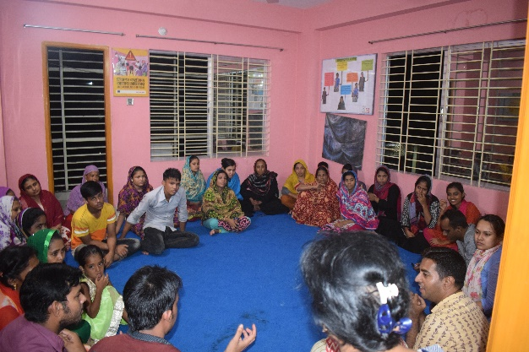
We come to the Café for our own cause. We can spend good time over here. Earlier some of our family members asked many questions why we come to Café. Now no one ask any question.

Parvin
Café Member
Mirpur, Dhaka

The Café members felt that they were able to learn about their rights and benefits at the workplace through the Café. They also learned how to realize their rights. They became aware about their own behavior and responsibilities. They were not able to protest against injustice in the factory. Now they can raise their voice against the irregularities that include terminating workers without good reason, irregular payment, misbehavior by the management, not getting due holidays etc. They also realized that in many cases, the factory management had to change their malpractices. They now pay minimum respect to the female workers. Female workers are also getting respect by their family members.
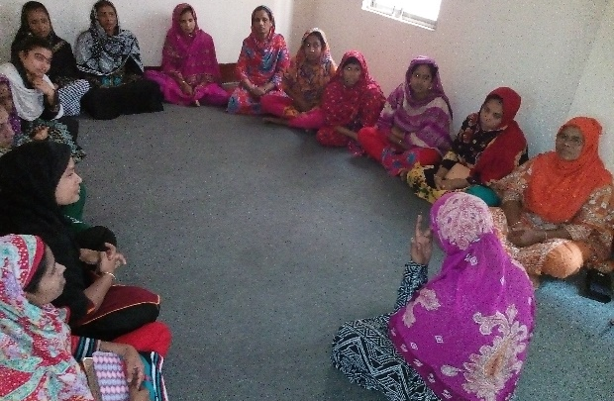
Workers Café has opened up our pathways. We can get everything we need from the Café.

Jesmin
Café Member
Mirpur, Dhaka

Despite having many achievements, the Café staff faced number of challenges in running the Café efficiently and smoothly. Initially it was very difficult to bring the workers in the Café for two main reasons. First of all, workers had little time to spend due to work load and secondly, there was an issue of trust. As a result of continuous effort made by the project staff, it was possible to build the trust among the workers. The Café was open during weekends to accommodate workers preference and the Café staff sacrificed a lot to make it happen. Café members were at risk of being terminated from their work when they became aware about their rights and raised voices. The Café staff closely worked with the factory management to minimize this challenges.
There are many challenges to sustain the benefits of the Café related activities, especially it is a big challenge to continue its services at a minimum level after phasing out of the SRAMIC project. Based on the discussion with Café members, Café staff and other concerned personnel, following recommendations are made for consideration.
- It may be possible to continue services through bringing the Café under a kind of organizational structure and providing minimum technical and financial support.
- Efforts may be taken to strengthen the services through linking up the Café with the existing Trade Union organizations.
- Efforts may be taken to ensure financial sustainability of the Café through creating income generating opportunities at the Café.
- Efforts may be taken by the Donor and partner organizations to absorb Café related activities partly or fully into other on-going or new projects.

Participation of female workers in Collective Bargaining and Participatory Committee

In Bangladesh, opportunity for the workers of RMG sector to organize themselves under trade unions is very limited. According to the Labour Act, formation of trade union is a fundamental rights of the workers. However, instead of efforts made by different entities, the RMG sector employers are reluctant to allow trade union activities in RMG sector. As an alternative, “Participatory Committees” have been formed in many factories consisting equal number of representatives from workers and employers. The main function of this committee is to ensure peaceful working environment in the factories through resolving various complaints and demands raised by the workers.
Most of the factories have formed this participatory Committees to satisfy the requirement of the foreign buyers. As a result, question has been raised about the effectiveness of these committees. There are instances that these committees do not organize regular meeting, selection of members often biased and do not concentrate on the genuine issues/concerns raised by the workers. In that context, SRAMIC project initiated some efforts to make these committees effective as well as forming new committees in factories who do not have such committees. Moreover, the project aimed at increasing the number of female workers in the Participatory Committees.
It was found from the representatives of the partner organizations, factory management and members of the Participatory Committees that in most of the factories within the project area, Participatory Committees have been formed. Some new committees have also been formed as a result of project initiative. However, most of the existing committees have been failing to fulfill its desired objectives mainly because the factory owners are not serious about it. As mentioned above, most of the factories formed these committees simply to satisfy the buyers as opposed to the protection and welfare of the workers. As a result, committee members do not meet on a scheduled basis and in some cases, collect signature of the members in the resolution book without having the meeting. Some of the small problems like supplying pure drinking water, separate toilet for female workers etc. have been resolved.
Alongside with the failures there are some achievements derived from these participatory Committees. For example, number of female members in the committees have been increased as result of project initiatives. According to the findings, two-third members of the commiittees are now female workers and majority of them belong to Workers Café and aware about the rights of the workers. Therefore, they have been trying to bring the workers’ rights related serious issues and being successful in some cases.
Realizing un-enjoying leave benefits of 1000 workers under the leadership of Participatory Committee members and trade union leaders
Rita, Ruma, Ismat Ara, Nurun Nahar, Asma and Kulsum work in GMCL garment factory in Mirpur -1 and associated with SHRAMIC project through Mirpur Café since 2017. They attended No-class training and learned about workers’ rights including leave benefit. Accordingly they demanded compensation against their un-enjoyed leave to the factory management on 7 February 2018. After receiving the demand the factory authority talked with the workers and promised to pay the money within the same month, though they did not mention any specific date.
The workers did not get any positive response within the month and discussed the issue with the members of the Participatory Committee on 15 February 2018. The committee members asked the workers to continue their work assuring that they will talk with the factory management. The workers followed the same. On the same day the Participatory Committee members raised the issue with the Compliance Manager. She told them that the workers will get money only for overtime. Committee members wanted to know the reason why the workers will be given compensation only for overtime and why not un-enjoyed leave. The Compliance Manager replied that the authority won’t be able to pay for these two benefits at a time.
Under such situation, Participatory Committee Members discussed the matter with the Cell Leaders of the Café. The Cell Leaders advised to receive the compensation for un-enjoyed leave first. Accordingly all the workers asked for the un-enjoyed leave compensation on 16 February and factory management paid total money on 19 February. This is how 1000 workers were able to get 38 lac Taka from the factory management.

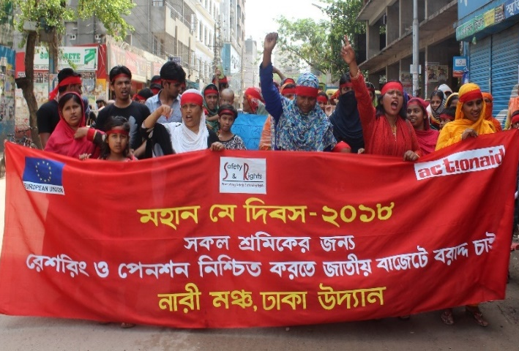
When we raise our genuine issues in the Participatory Committee meeting, the representatives of the owners tell us that we became smarter and clever and they report to the Production Manager against us.

Dipa
Participatory Committee Member
Mirpur, Dhaka

There are questions regarding the effectiveness of the Participatory Committees in realizing the demands of the workers through collective bargaining. Although there are equal number of members from workers and factory owners, however, in most cases, representatives of the factory owners dominate everything in favor of the owners. Therefore, there is no alternative than formation of trade unions at factory level.

Role of Local Trade Unions to Realize the Rights of the Workers

The role of trade unions is crucial to realize the rights of the workers. In doing this successfully, it is essential for the trade union leaders to have adequate knowledge and skills regarding the legal rights of the workers. However, in many occasions, the trade union leaders and members in Bangladesh lack required level of knowledge and skills. As a result, they often fail to realize the rights of the workers. In that context, the SHRAMIC project took an initiative to develop knowledge and capacity of the trade union members and leaders so that they can expedite the process of realizing the rights of the workers through effective collective bargaining. As part of this initiative the project closely worked with the local trade union bodies in the project area.
Four types of trainings were provided to trade union members. These are: Labour Law and Labour Rights, Good Governance, Negotiation and Fund Raising. As a result, trade union members became aware about the rights of the workers in line with the Labour Act. Side by side, they also gained knowledge and skills on the rules and regulations for running organization, collective bargaining and how to run the organization efficiently.
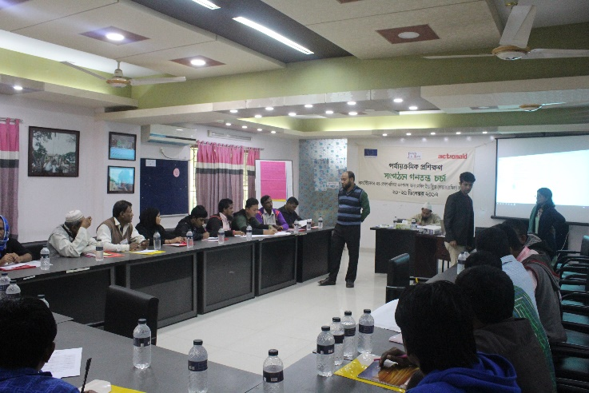
We are working with SHRAMIC project from the very beginning. Many of our members received training from this project. They are now aware about Labour Act and working to make other members aware. Already two trade unions have been formed in the factory. As a result, the process of realizing the rights of the workers has been strengthened.

Morshed Alam
President
Bangladesh Sramic Songhoti Federation Chottogram
I and my other members have received first training from the SHRAMIC project. Now we are aware about the key provisions of the Labour Act. We are now trying to strengthen the movement for realizing the rights of our workers.

Jostna Akter Daisy
Vice-President
Democratic Garments Workers Federation
Chottogram

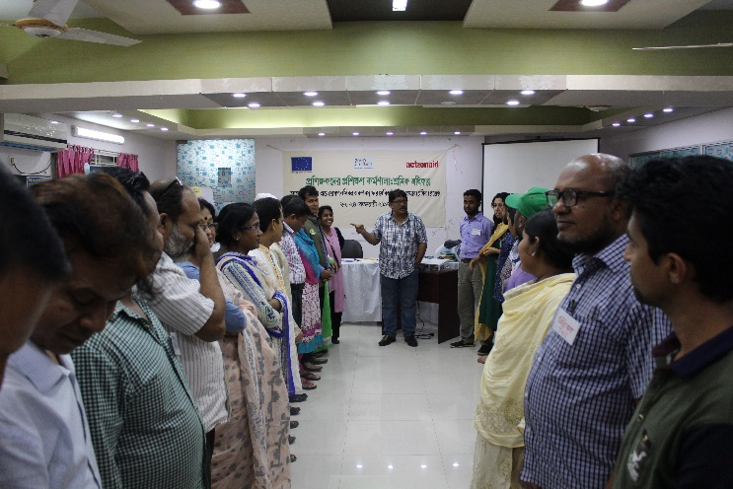

Trade Union members have been taking different initiatives to organize other unorganized workers. Firstly, they are trying to create awareness among the workers regarding Labour Law and rights of the workers. Secondly, they are holding dialogues/discussions with the factory authorities to resolve various disputes. Thirdly, they organize meetings, seminars, human chain etc. on the occasion of national international days related with workers.
The Tannery workers were totally in dark regarding labour rights and Labour Act. Under that situation the SHRAMIC project came to us. They made a significant contribution over the last three years to raise awareness among the Tannery workers. They can now bargain with the factory authority to realize their rights.

Abul Kalam Azad
President, Tannery Workers Union

The trade union members have achieved a good number successes at personal and group level through collective bargaining with the factory authorities. These include realizing due payment of the terminated workers, realizing compensation for workers against un-enjoyed annual leave, ensuring pure drinking water for the workers, placing alternative ladder at the factory, assigning separate toilets for female workers, assigning rest room for mother with children, realizing maternity leave etc. Besides, they have been able to change the attitude of the senior management and senior staff. Moreover, they have been able to get recognized by the factory authorities. There are many owners who have now faith on the trade union members and consult with them to maintain discipline in the factory and improving the working condition.
There were some challenges as well. It was difficult to mobilize workers as majority of the workers are not aware regarding their rights and entitlements. And workers often at risk of being terminated due to their engagement with trade union activities.

Positive Attitude of the Factory Authority is a Pre-condition for ensuring Safe Working Environment

Despite having various adversity in the RMG sector in connection with the workers’ rights, some factories have taken positive initiatives to create favorable environment in their factories. These factories have been able to create workers-friendly environment through implementing key provisions of the Labour Act. And it was possible due to changed attitude of the factory owners, willingness of the senior officers and respect towards the law. This case study has been prepared based on the factory visit and discussion with the representatives of workers and owners.
Urmi garments limited is located in Tejgaon area of Dhaka City. Approximately 1,300 workers are working in this factory. The factory authority has been supporting SRAMIC project from the beginning. They have sent participants (workers) to the trainings organized by the project without deducting salary. The Assistant General Manager (Admin, Human Resource and Compliance) said “We believe that it will be an advantage for us, if our workers are aware about Labour Law. They may be misguided by vested interest groups if they are not aware. We can work together with the workers if they are aware. That is why we sent them to the trainings organized by SHRAMIC project. Many of them are the members of Workers Café.”
Urmi garments has been able to establish Participatory Committee and Safety Committee. Members of these committees can raise their voice and factory management pay full respect to their concerns. This garments pay salary to their workers by 10th of each month. There are no cases in the labour court. All issues are being settled in consultation with the workers.
------------------------------------------------------------------------------------------------------------------------------------------
Polka Dots Fashion is located at Mirpur Industrial plot. They are closely working with SHRAMIC project from the very beginning. This factory is not a fully compliant factory. However, motivated by the SRAMIC project they have formed participatory Committee, Safety Committee and Anti-Harassment Committee. Allowing formation of trade union is under process.
There are 12 members in the Participatory Committee and they meet once in a month. They discuss about issues related to maintaining discipline at the factory, problems of the workers, salary, bonus, code of conduct etc. The factory authority believe that effectiveness of these committees is beneficial for both workers and factory owner. Workers don’t require to go for any movement for realizing their demands.
----------------------------------------------------------------------------------------------------------
Delux Fashion Ltd. is a sister concern of Clifton group in Chottogram. Approximately 3,000 workers are employed in this garments. The local implementing partner has been closely working with this factory from the beginning of the SHRAMIC project.
The General Manager of Delux Fashion said “It is always difficult to run the factory smoothly without having good relationship between workers and factory management. Although many factories don’t think over this issue. We are running the factory based on the provisions of Labour Act. We send our workers to training organized by SHRAMIC project so that they can have a clear understanding about Labour Law. Majority of our workers are now aware about Labour Act and we can talk in same language.”
This factory has issued employment letter to all its workers. Participatory Committee has been formed through election. Trade Union is functional since 2012. Training has been arranged for mid-level staff by the factory.
This types of positive initiatives really encouraging despite having many negative practices. Efforts should be taken to encourage more factories through wider dissemination of these good practices. The non-compliance factories may be encouraged to comply with existing laws once the compliant factories will be given recognition in an appropriate manner.

Young Leadership created hope for realizing workers’ rights

Youth leadership is invisible in almost all sectors in Bangladesh. This is equally applicable for labour movement. Whereas youth leadership is crucial for organizing the workers and realizing their rights. Youth leaders can motivate and organize workers and will be able to bargain with the employers using their intelligence. In that context, SHRAMIC project took the initiative for creating young leaders and developing their capacity.
A group of young members from the workers’ café was identified and they were provided with knowledge and awareness on labour rights and Labour Law through non-class training. Besides, they were given the opportunity to participate in the implementation process of various project activities in order to develop their organizational capacity. These young leaders are now fully aware regarding labour rights and Labour Law. They have been contributing towards creating awareness among other workers, placing demands of the workers before the factory authority through Participatory Committees, identifying and resolving workers’ problems through visiting different factories and bargaining with the factory management, liasing with trade unions to resolve workers’ problems and observing national and international days related with women and workers’ rights.
The trained new leadership has already achieved many successes. They have been able to creating awareness among other workers, especially young workers through non-class training. They have also been able to engage young workers in workers movement. Their activities are not limited within the factories, but also in the community they live-in. They are fighting against child labour, early marriage etc.
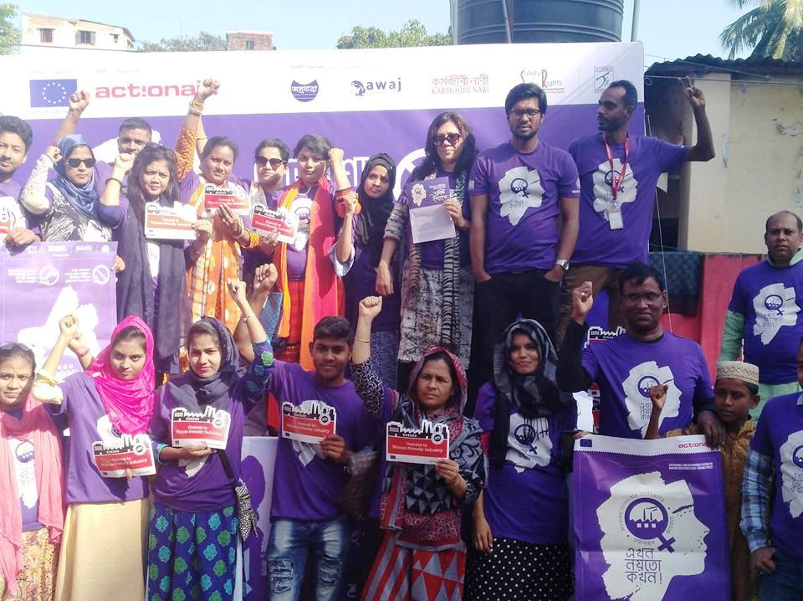
As a worker I used to felt that I am not a person of worth. After receiving training I realized that we are important part of the society. As a young leader my responsibility is to make other workers aware about their rights and organize them. We need new strategy to bring about positive changes in the lives of the workers.

M. A. Hyder Ali
Member, Young Leader Forum
Hemayetpur, Savar

There are challenges to mobilize young workers as well. In many occasions, workers are wrongly motivated by the factory management and creating obstacles, as all workers are not aware about labour rights and labour law. At the same time the factory management creates various obstacles, including threat of police case, terminating from work etc. Many young workers lost their job due to their involvement with labour rights related movement.
The young leaders has got some plans to continue their activities beyond project period. They have planned to increase the number of members and collecting minimum subscription for economic sustainability. Besides, they are planning to get registered under the Directorate of Women Affairs. They will need technical and financial support from the partners after phasing out of the project in order to continue their efforts effectively. They are the future leaders and they will be able to add new dimension in the workers’ movement through applying logic, intelligence and new strategy.

Demand for minimum wage and mass termination

History of labour movement for realizing minimum wage in the RMG sector is very old. The last movement occurred in December 2018 and January 2019. The minimum wage for RMG workers was declared for the fifth time in December 2018. Taka 8,000 was set against Taka 16,000 demanded by the workers’ organizations.
On one hand, the amount set as minimum wage was half of the demand and on the other hand, there was mismatch between different grades. As a result the workers went for movement. The factory owners applied two strategies to disperse workers’ movement. Firstly, they filed number of cases against the worker leaders and secondly, they went for mass termination. A good number of workers have been facing inhuman situation as a result of mass termination. Many workers became victims of mass termination, although they were not involved with the movement.
Md. Abu Sayeed and Sohel used to work in a garments factory in Tongi area. Sohel was the Vice-Prosident of Sommilito Garments Shramic Oikko Parishad and Abu Sayeed was a member of the same organization. On 7 January 2019, a group of 48 workers went to talk with the Compliance Manager of their factory to resolve grade related complicacy. Their demand was that they were not given the same grade wise salary like other garments factories. Compliance manager told them that he will discuss with the management and let them know.
The workers did not work on 8 January. They left the factory at 5 p.m. On 10 January the Owner of the factory requested them to resume work giving a hope that he will look into the matter. An agreement was signed between workers and owners on the same day. According to the agreement, workers will get same amount of salary like other factories. They were given the salary for January and it was agreed that the additional amount will be given with the salary for February. On 9 February workers from other factories attacked this factory. Sohel, Abu Sayeed other workers fought against them and protected the factory. Sohel got married on 11 January and a good number of senior officials of the factory attended the program. However, on the same night Police arrested Sohel from his residence. Abu Sayeed was also arrested form his residence.
There was no specific allegations against them. They were showed missing for two days. On 15 January a case was filed against them in connection with vandalizing factory. They got bail after ten days. The case is still going on and they have to produce themselves before the court every month. They tried to get a job in other factories, but denied. Their pictures were shared with all garments. Sohel has become a rickswa puller to survive with family members. Abu Sayeed is still unemployed.
There were many other workers like Sohel and Abu Sayeed who became the victims of mass termination and majority of them failed to get a job. The factory authority paid dues of all these workers and they claimed that they have terminated these workers following the relevant section of the Labour Act.
Trade Union leaders associated with the SHRAMIC project prepared the list of terminated workers in their respective areas and tried to get back their job through dialogue/negotiation with the factory authority. However, little success has been achieved so far. The factory authority claimed that they had to reduce the number of workers for minimizing cost, however, most of the workers and trade union leaders felt that it was done only for making the workers’ movement weak. It is difficult to say what role the trade union organizations can play to address this types of situation. One of the solutions would be fighting for realizing the rights of trade union activities in RMG sector. At the same time, efforts should be made to make sure that these terminated workers to have access to legal support.

